**Data Types**

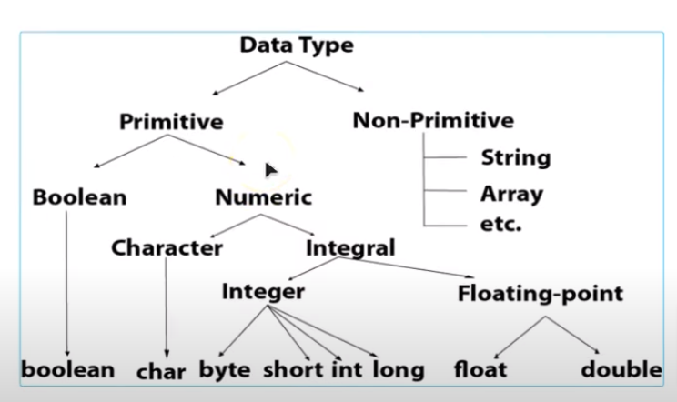

**Primitive:** Means Pre-Defined Data types.

**Non-Primitive:** Means User-Defined Data types. Ex: class, function etc.

Note: In some programming languages, String comes under Primitive Data types due to the absence of char data type.

**Range of Data Types:-**

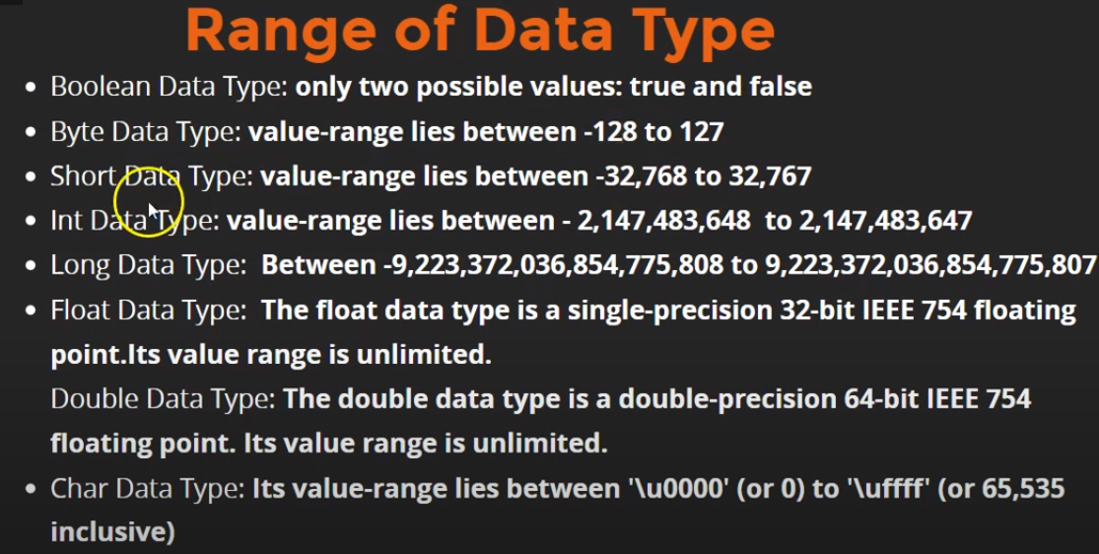

**Size of Data Types:-**

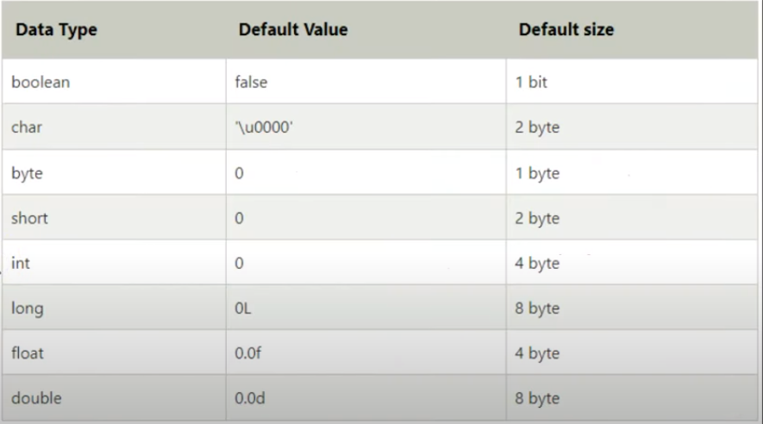

**Interview Questions:-**

1. Can we store int value in float data type?

Yes, we can but we can’t store float value in int data type.  
Ex:  
int num1 = 10;  
float num2 = 10f; //But it will return 10.0  
  
But we can’t do like this,  
int num1 = 10.2;

1. Can we store 150 in byte data type?  
   No, we can’t. Because the range of store value in byte data type are -128 to 127.
2. Why need f at last in float data type?

To convert the actual value to the float value.  
Ex: 0.1f == 0.1 false  
Because, the actual value of 0.1 is   
0.1000000000000000055511151231257827021181583404541015625  
which can’t be store in variable of float data types due to its range.  
So, 0.1f will get converted into this  
0.100000001490116119384765625  
which can’t be store in variable of float data types because it comes under its range.

1. How to make a long Data type?  
   Similarly, by placing ‘l’ after long value, it converted an actual to the lone one.
2. Can store ‘1’ in char data type?

Yes we can, but we can’t store ‘11’ in char data type because it’s string.

1. How to indentify Data Type Categories (Primitive or Non-Primitive)?

The first letter of Primitive data types always in Lowercase.

Ex: int, float, long, double, Boolean etc.  
On the other hand, The first letter of Non-Primitive data types is always in Uppercase.  
Ex: String, Array etc.